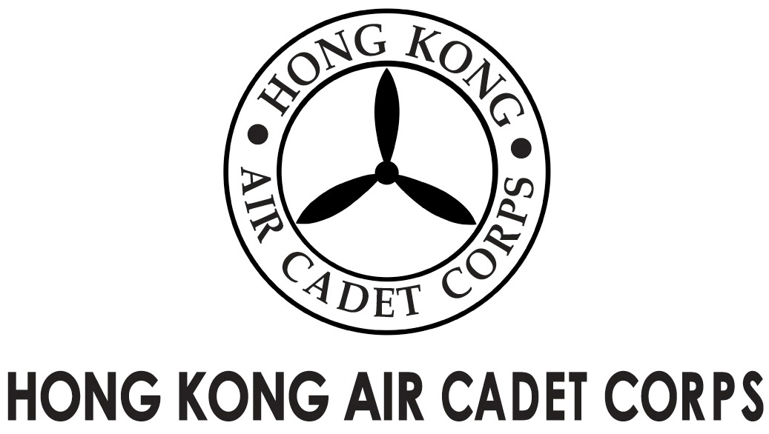

From | OC A&S Gp  (michael@etoileconsultants.com) | To | OC No.1 thru 6 and C Wings  Major Unit Commanders
Our Ref | GOSA/2015/1 | # of Pages | 2
Date | 17/11/2015 | Your Ref

Grantham Uniformed Youth Groups Outstanding Service Award
葛量洪青少年制服團隊傑出服務獎

Invitation for Recommendations

Introduction

The Grantham Scholarships Fund Committee (“the Committee”) is now inviting two nominations from the uniformed youth groups for the “Grantham Uniformed Youth Groups Outstanding Service Award” (“the Award”). The Corps will nominate two candidates to the Committee. To facilitate the nominations, we are now inviting OC No. 1, 2, 3, 4, 5, 6 and C Wg to recommend two potential candidates who qualified the selection criteria and are worth the honour. Two successful candidates among your recommendations will be put forward by a selection panel of the Corps through respective interviews.

Background

Each awardee of the Award will receive HK$8,000. The results of the award will be announced by the Committee’s Secretariat in February 2016 tentatively.

Selection Criteria

- persons resident in Hong Kong who are pursuing local education;
- members possess good character and demonstrate a high level of leadership and strong commitment to the organization;
- all-round members who are both active in participating in regular training activities and devoted in taking part community services;
- members have not been awarded the Award previously;
- members who are NOT above 21 years of age;
- a cadet member for at least 5 years;
- members who have accumulated at least 200 service/training hours (including 50 service hours) over the past 12 months; and
- candidates perform successful appearance before a selection panel.

Recommendation Procedure

OC Wings should submit the application forms to HQ copied DCO Ops (for No.1 thru 6 Wg) or DCO Trg (for C Wg) by 1/12/2015 1700 hours.

Selection Schedule

On or before 1/12/2015 – all official recommendations should be submitted to HQ via emails

On or before 3/12/2015 – candidates will be informed to attend a selection panel interview

On or before 9/12/2015 – successful candidates will be announced

On or before 11/12/2015 – two nominations of the Corps will be sent to the Committee

Should you need any further information or enquiry, please contact Fg Off Kris KWONG (kriskwong@ymail.com) Adjt A&S Gp. Thank you in for your kind facilitation.

Kris KWONG
Fg Off
for OC A&S Gp

The “Grantham Uniformed Youth Groups Outstanding Service” Award
葛量洪青少年制服團隊傑出服務獎
2015-2016

Application Form

This application form must be submitted to HQ copied to DCO Ops (for No. 1 thru 6 Wg) or DCO Trg (for C Wg) by 1/12/2015 1700 hour. Late submission will not be considered.

A) Personal Particulars

English Name: |  |  | Chinese Name:
Serial Number: |  |  | Rank:
Unit: | Birthday: |  | Gender:
Tel: (Home) |  | (Mobile) | Over 200 Service/Training hours: Y/N
Current School: |  |  | Email:
Class / Programme:

B) Community Service Records (in last 12 months)

Service | Date | Venue | Service Hour
Total:

C) Essay

Please write an essay of 500 words or more on a topic relating to either the training activity or the community service.

D) Declaration

I declare that the information provided are true are complete. Any misrepresentation, concealment of facts or false information will lead to disqualification of my application.

Signature of Applicant: Date:

